# Assignment Sheet

|  |  |
| --- | --- |
| **Course and instructor name** | Game Dynamics 1 – Dr. Umer Noor |
| **Assignment name** | Assignment 2 – Building a world class and projectile motion |
| **Grade value** | 20%  Rubric attached |
| **Due date** | Week 6 |
| **Individual or group assignment** | Individual |
| **Submission instructions** | Show in class and submit on Blackboard |
| **Targeting these learning outcomes from course outline** | 1. Use the equations of motion in 1D, 2D, 3D 2. Use Newton's Laws to predict motion. 3. Use vector addition to determine the net force on an object 4. Create simulations that incorporate key concepts of this course |

## Instructions

1. Build a world class like this diagram (does not need to be exactly the same, feel free to use your own style). The job of the World class is to keep track of all the bodies in the world and update them when its Update method is called. It also handles things like keeping track of time, applying acceleration due to gravity to bodies, and applying wind forces to bodies for this lab.

|  |
| --- |
| **Class or Struct name**  World |
| **Data members**  // Scott prefers we leave std::vector for later, lets just use arrays instead  // std::vector<Body*> bodies // A vector list of Body pointers  Body bodies[2] // An array of 2 bodies  double elapsedTime  Vector2D gravityAcceleration  Vector2D windForce |
| **Constructor and Function members**  World(Vector2D& initialGravityAcceleration, Vector2D& initialWindForce) // The constructor  // We don’t need a destructor if we are not creating a vector list of Body pointers  // ~World() // The destructor. Delete the Body pointers  // AddBody below is for the vector list. We’ll just build one to add two bodies to the array  // void AddBody(Body* body) // Add a Body pointer to the vector list of bodies  void AddTwoBodies(Body body1, Body body2) // Add two bodies to the array of bodies  void Update(double timeStep) // Update all the bodies |

1. Create a new world with a gravity acceleration of [0, -9.8] and a wind force of [0, 0].
2. Add two bodies to the world with masses 2kg and 4kg respectively.
3. Place both bodies at position [0, 200] to start.
4. Apply a force of 1000N in the positive x direction to both bodies on the first frame (do not continue apply force after that).
5. Using a timestep of 0.1s, start your simulation. Write the current time and the positions of both bodies to a file called “gravity.csv”. Note that a “csv” file is a comma separated values file (e.g. 1, 2, 3) that can be read by Excel. Feel free to write to the console as well. **See the table below for a suggestion of how to format your output.**
6. Stop simulating after both bodies have fallen below 0 on the y axis.
7. Open gravity.csv with Excel.
8. Create a scatter chart plotting the x and y positions of both bodies. This graph shows you the path your bodies took through the 2D world.

**Answer in Excel: Why does one body move further in the x direction than the other?**

1. Create another scatterplot of the y positions of both bodies through time. This graph shows you how far your bodies were from the ground as time passed in the simulation.

**Answer in Excel: Why do the plots for both bodies look the same even though the masses of the bodies are different?**

1. Save your spreadsheet with graphs as “gravity.xlsx”.
2. **Repeat steps 2 through 7 using a new world with a gravity acceleration of [0,-9.8] and a wind force of [-20,0]. This time your output file will be called “gravityWithWind.csv”.**
3. Open gravityWithWind.csv with Excel.
4. Create a scatter chart plotting the x,y positions of both bodies. This graph shows you the path your bodies took through the 2D world.

**Answer in Excel: How does inertia (mass) affect the way that wind acts on the bodies?**

1. Create another scatterplot of the y positions of both bodies through time. This graph shows you how far your bodies were from the ground as time passed in the simulation.

**Answer in Excel: Why does this plot look the same as in the previous simulation even though wind forces are now acting on the bodies?**

1. Save your spreadsheet with graphs as “gravityWithWind.xlsx”.

**Use this table as a guideline for how to format your output in your .csv (comma separated values) files:**

|  |  |  |  |  |
| --- | --- | --- | --- | --- |
| Time (s), | Position x 1 (m), | Position y 1 (m), | Position x 2 (m), | Position y 2 (m) |
| 0, | 0, | 200, | 0, | 200 |
| 0.1, | 2.5, | 199.9, | 1.25, | 199.9 |
| so on… | … | … | … | … |
| … | … | 0 (or less), | … | 0 (or less) |

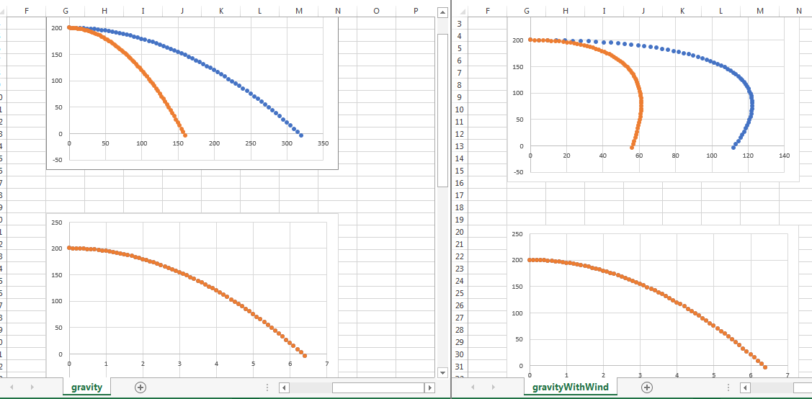

|  |  |  |  |  |  |
| --- | --- | --- | --- | --- | --- |
| Rubric | | | | | |
|  | 4% | 3% | 2% | 1% | 0% |
| **World class** | Coded extremely well and wonderful comments | Coded to specifications | Missing or broken functionality | Missing lots of detail | Largely empty |
| **Test case 1 (Gravity)** | Test case coded well and outputs well-formatted table. Graphs are correct and conclusions are presented clearly. | Coded to specifications | Missing or broken functionality | Missing lots of detail | Largely empty |
| **Test case 2 (Gravity with wind)** | Test case coded well and outputs well-formatted table. Graphs are correct and conclusions are presented clearly. | Coded to specifications | Missing or broken functionality | Missing lots of detail | Largely empty |
| **Presentation** | Able to explain code and concepts very well in person and handle live-coding easily | Satisfactory presentation of work done | Not able to explain all code or cannot make certain changes | Somewhat confusing or vague | Very confusing. Unsure student understands any code |
| **Process** | Pieces of the assignment have been steadily building throughout the time given. Creativity used to solve key problems. Able to reflect on what they could improve on. | Assignment completed satisfactorily | Somewhat of a rush to complete assignment | Obviously has been a big last-minute rush to complete assignment. No time for creativity or reflection | Student has not spent any time grappling with concepts, reaching out for help, or reflecting on topic |

**Grading standard:**

20/20 - Work so amazing the instructor would only see this once in a lifetime

18/20 – Exceptional work, rare

16/20 - Great work, student has full command of the topic.

13/20 - Minor errors

10/20 - Errors and perhaps a major error

8/20 - Regular and consistent major errors. Lack of understanding

4/20 - Largely empty